**CS310 Data Structures**

**Midterm 2**

**Total Points: 100 Number of Questions: 5**

**Name:**

**REDID:**

***Please read the questions thoroughly before answering.***

***Submit the exam as a PDF (written & scanned / filled in word and exported)***

1. (20 points total)

The following code for a binary search tree is given:

public class TreeNode<K extends Comparable<K>,V>{

private K key;

private V value;

private TreeNode<K,V> leftChild;

private TreeNode<K,V> rightChild;

}

public class BinarySearchTree<K extends Comparable<K>,V>{

private TreeNode<K,V> root;

public void insert(K key, V value) { ... }

public void delete(K key) { ... }

public SomeType find(int key) { ... }

}

Assume that the method bodies are complete and work as intended.

Write **JAVA CODE** for the following:

(a)(8 Points) Add a method **public int treeHeight()** to the BinarySearchTree class that computes the height of the tree.

(b)(8 Points) Add method **public void deleteMax()** to the BinarySearchTree class that deletes the maximum element in the tree (or does nothing if the tree has no elements). You may want a helper method. (c)(4 Points) For your answers in part (a) and part (b), give a worst-case big-Oh running time in terms of n, where n is the number of nodes in the tree. Do not assume the tree is balanced.

**<<SPACE FOR WRITING CODE>>**

1. (20 points total)
2. (4 pts) What is the minimum and maximum number of nodes in a balanced AVL tree of height 5? (Hint: the height of a tree consisting of a single node is 0)

Give an exact number (with no exponents) for your answers

Minimum =

Maximum =

1. (4 pts) What is the minimum and maximum number of nodes in a full tree of height 6?

Give an exact number (with no exponents) for your answers – not a formula.

Minimum =

Maximum =

1. (4 pts) What is the minimum and maximum number of non-leaf nodes in a complete tree of height 5?

Give an exact number (with no exponents) for your answers.

Minimum =

Maximum =

1. (1 pt) What is the depth of node **P** in the tree shown below:

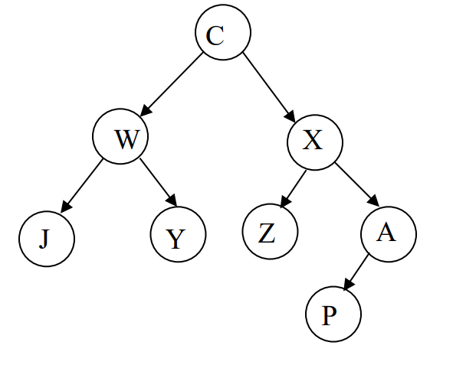

1. (1 pt) Give a **Pre-Order** traversal of the tree shown above in (d)
2. (6 pts) Given the following six trees a through f:

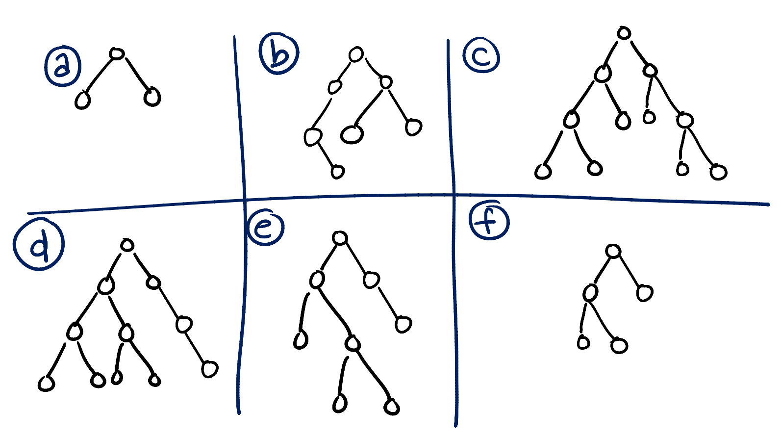

List the letters of all of the trees that have the following properties: (Note: It is possible that none of the trees above have the given property, it is also possible that some trees have more than one of the following properties.)

**Full: _______________________**

**Complete: _______________________**

**AVL balanced: _______________________**

1. a) (11 points) AVL Trees Draw the AVL tree that results from inserting the keys:

**20, 30, 90, 50, 40, 35, 10, 37, 31, 34**

in that order into an initially empty AVL tree.

Draw all intermediate trees and label all the rotations that happen.

3 b) (9 Points) Indicate for each of the following statements if it is true or false. You must justify your answers to get credit.

1. The subtree of the root of a red-black tree is always itself a red-black tree. (Here, the definition of red-black tree is as I have given in class and as described in the textbook.)
2. The sibling of a null child reference in a red-black tree is either another null child reference or a red node.
3. The worst case time complexity of the insert operation into an AVL tree is O(log n), where n is the number of nodes in the tree.
4. (20 Points) Given the following integer elements:

30, 65, 22, 40, 15, 70, 80, 60, 55, 10

For a and b Show all intermediate steps for full credit. You do not need to show the array representation of the heap.

1. Draw the tree representation of the heap that results when all of the above elements are added (in the given order) to an initially empty maximum binary heap. Circle the final tree that results from performing the additions.

b. After adding all the elements, perform 2 removes on the heap. Circle the tree that results after the two elements are removed.

1. (20 Points) This problem implements a minimum priority queue using a queue. The queue is already implemented with a linked list in the LinkedListQueue class. Elements are added to the priority queue by being put at the end of the queue. The add method of the queue-based priority queue is implemented below. Finish the implementation of the class IntQueuePQ, a priority queue implemented using a queue, by **writing the remove method** **(Write JAVA CODE)**

**Method description:**

1. The remove method finds, removes, and returns the minimum element from the priority queue.
2. If the priority queue contains no elements and the remove method is called an **IllegalStateException** is thrown.

In order to write remove you may call any of the methods declared by the **IntQueue interface** on the queue instance variable found in **IntQueuePQ**. However, **you may not use any additional data structures or abstract data types** other than queue declared in the IntQueuePQ class in order to solve this problem.

public interface IntPriorityQueue {

public void add(int value);

public int remove();

}

public interface IntQueue {

public boolean isEmpty();

public void enqueue(int i);

public int dequeue();

public int size();

}

public class IntQueuePQ implements IntPriorityQueue {

private IntQueue queue;

public IntQueuePQ() {

queue = new LinkedListQueue();

}

public void add(int value) {

queue.enqueue(value);

}

// THE REMOVE METHOD WOULD GO HERE

}

**<<WRITE CODE HERE>>**